**AWT:-**

* Awt stands for Abstract window toolkit.
* Awt is used for graphical user interface programming in java.
* Awt is platform dependent.
* Awt is heavyweight.
* Java.awt package contain the api of AWT.

Any user interact with java program in two different way;

* CUI (Command user Interface)
* GUI (Graphical user Interface)

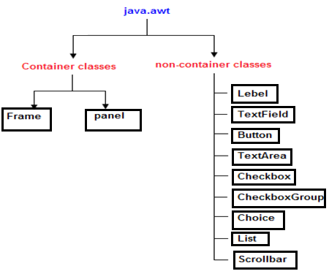

**Component:-**A **component** is an object having a graphical representation that can be displayed on the screen and that can interact with the user. Eg. Button,Label,checkbox

**Container:-**  Container can contain another components in java such as Button and label.

**Panel:-** The Panel is the container that doesn't contain title bar and menu bars. It can have other components like button, textfield etc.

**FRAME:-**The Frame is the container that contain title bar and can have menu bars. It can have other components like button, textfield etc.

**Methods of component class:-**

1. Public void add(Component c)
2. Public void setSize(int width,int height)
3. Public void setLayout(LayoutManager lm)
4. Public void setVisible(Boolean b)

**EVENT HANDLING:-**

* Changing the state of component is called event. Eg clicking on the button.
* Java.awt.event package contains the required class.

**JAVA EVENT CLASS AND LISTENER INTERFACE:-**

|  |  |
| --- | --- |
| **Class** | **Interface** |
| ActionEvent | ActionListener |
| MouseEvent | MouseListener and MouseMotionListener |
| KeyEvent | KeyListener |
| ItemEvent | ItemListener |
| TextEvent | TextListener |
| WindowEvent | WindowListener |

## **Registration Methods**

For registering the component with the Listener, many classes provide the registration methods.

For example:

* **Button**
  + public void addActionListener(ActionListener a){}
* **MenuItem**
  + public void addActionListener(ActionListener a){}
* **TextField**
  + public void addActionListener(ActionListener a){}
  + public void addTextListener(TextListener a){}
* **TextArea**
  + public void addTextListener(TextListener a){}
* **Checkbox**
  + public void addItemListener(ItemListener a){}
* **Choice**
  + public void addItemListener(ItemListener a){}
* **List**
  + public void addActionListener(ActionListener a){}
  + public void addItemListener(ItemListener a){}